NAME____________________________ DATE__________________
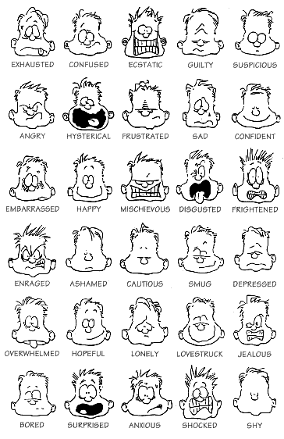
NAME____________________________ DATE__________________
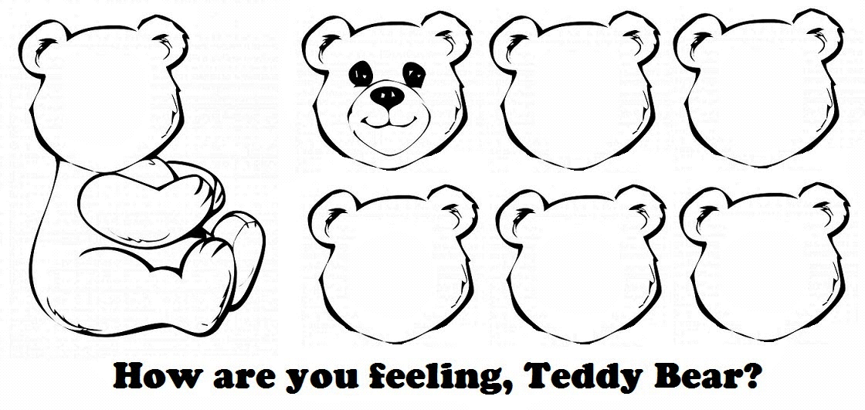

NAME____________________________ DATE__________________

