STUDENT: ___________________DATE:________
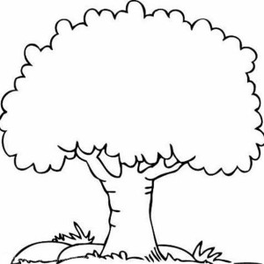
WHO?

GRANDMOTHER GRANDFATHER

MOTHER FATHER

SISTER BROTHER COUSIN

STUDENT: ___________________DATE:________
WHO?

GRANDMOTHER GRANDFATHER

MOTHER FATHER

SISTER BROTHER COUSIN

