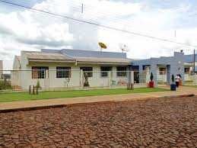

**presidente costa e silva SCHOOL**

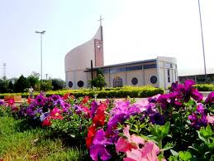

**são pedro CHURCH**

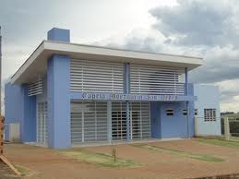

**MORTUARY CHAPEL**

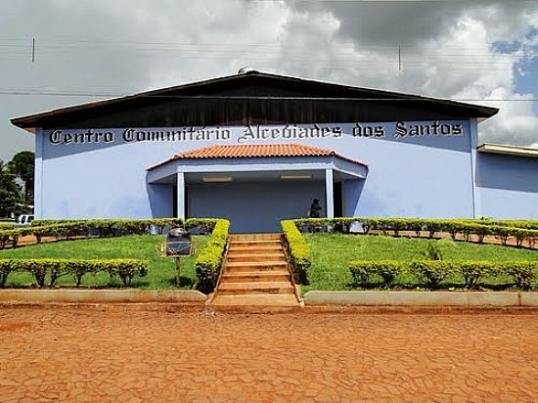

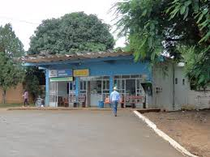 **EVENTS CENTER**

**BUS STATION**

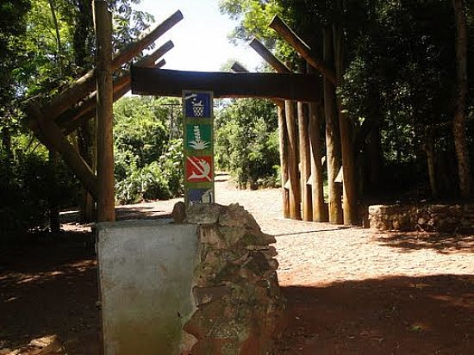

**FOREST RESERVE**

**cabeça do cachorro**

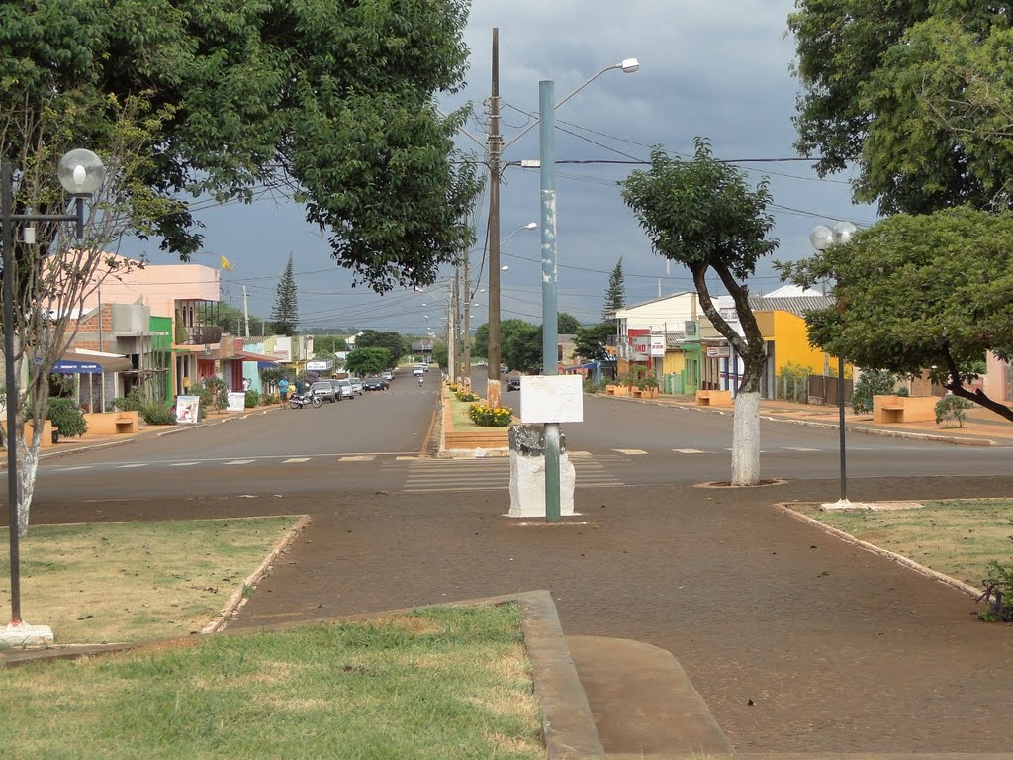

**são Paulo AVENUE**

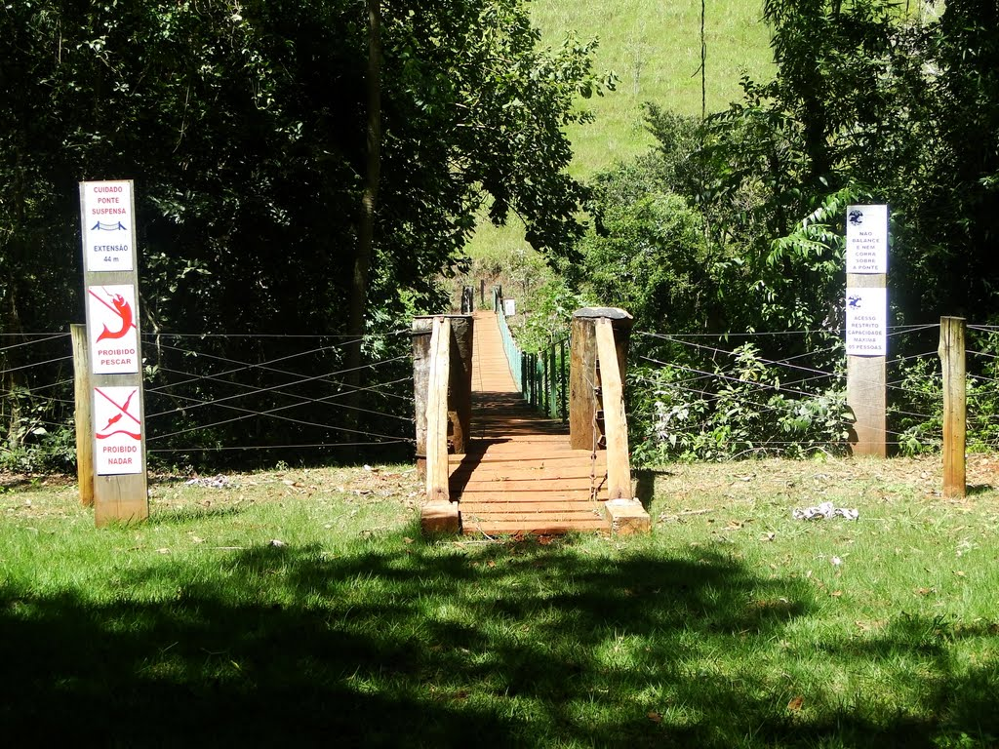

**cabeça do cachorro BRIDGE**

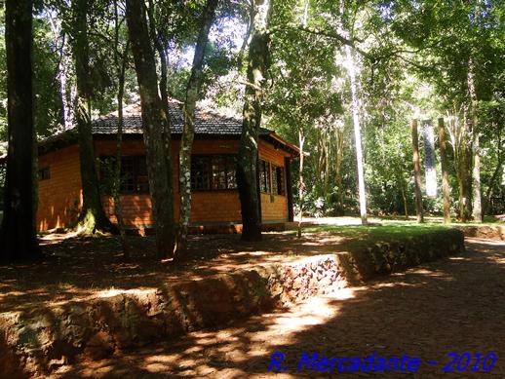

**cabeça do cachorro SCHOOL**

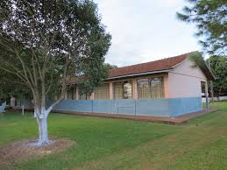

**são judas Tadeu RURAL SCHOOL**

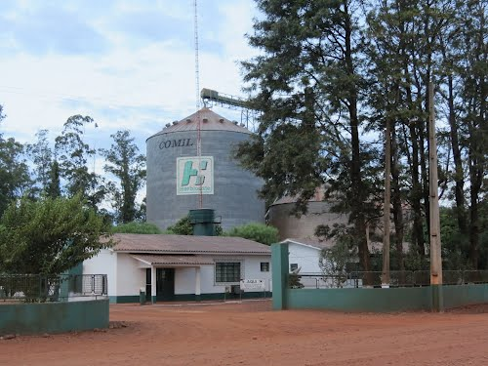

herbioeste

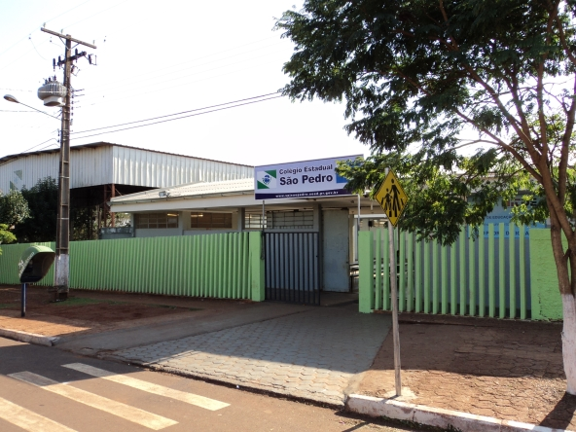

**são pedro HIGH SCHOOL**

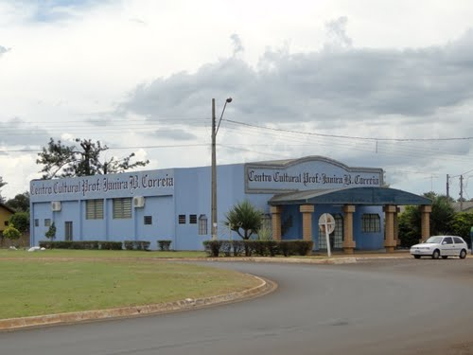

**culturaL CENTER**

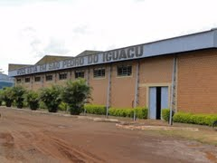 **gYMNASIUM**

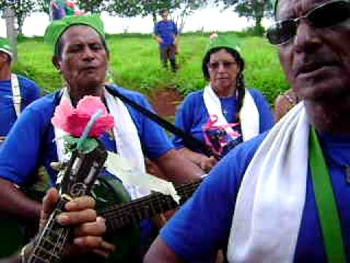

**foliões de santo reis – CULTURAL ACTIVITY**

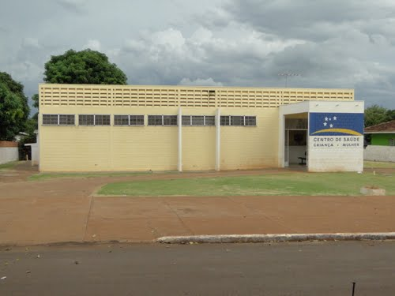

**WOMEN’S CLINIC**

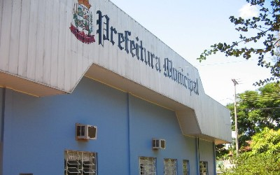

**são Pedro do iguaçu CITY HALL**

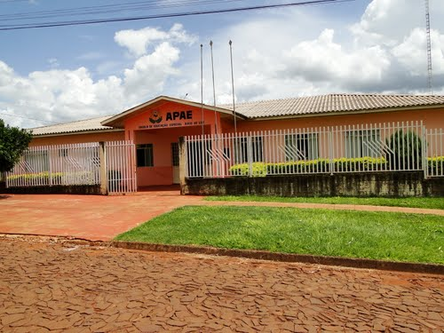

**Apae raio de luz – SPECIAL SCHOOL**

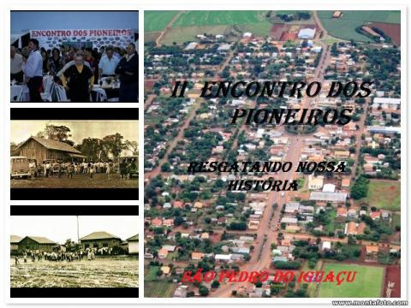

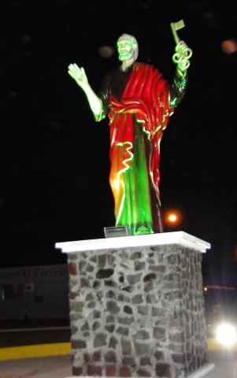

**são pedro do iguaçu CITY GATEWAY**

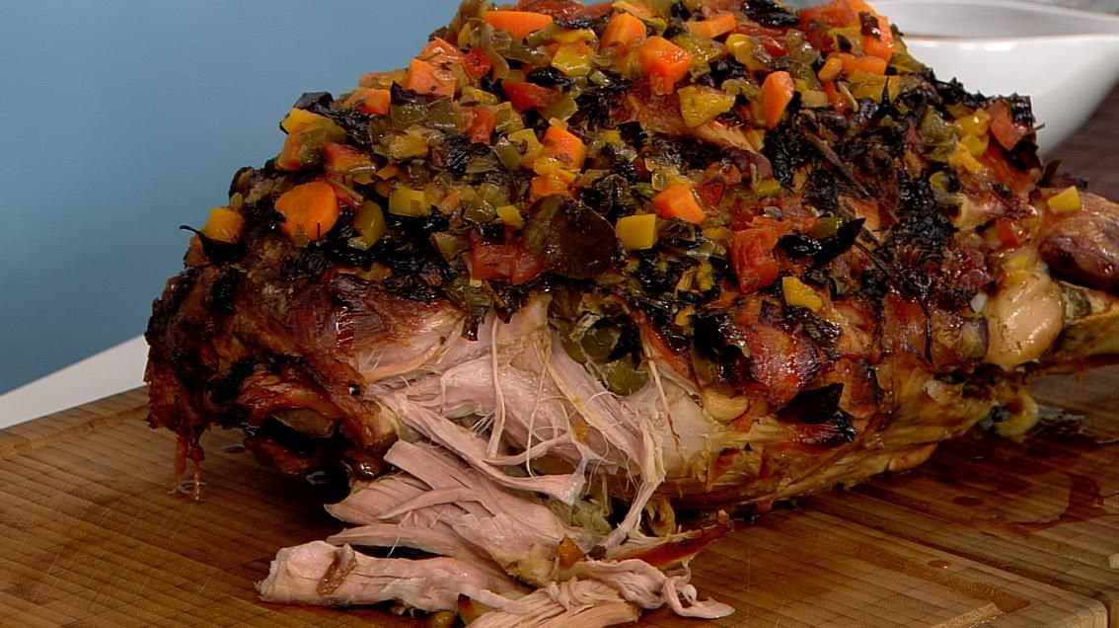

**TRADITIONAL FOOD BONELESS HAM**

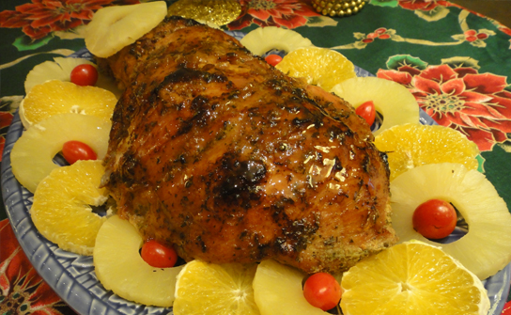

**TRADITIONAL FOOD BONELESS HAM**

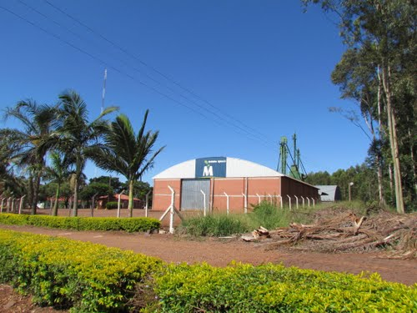  **Iguaçu MILL**

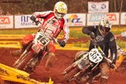 **MotoRCYCLING**