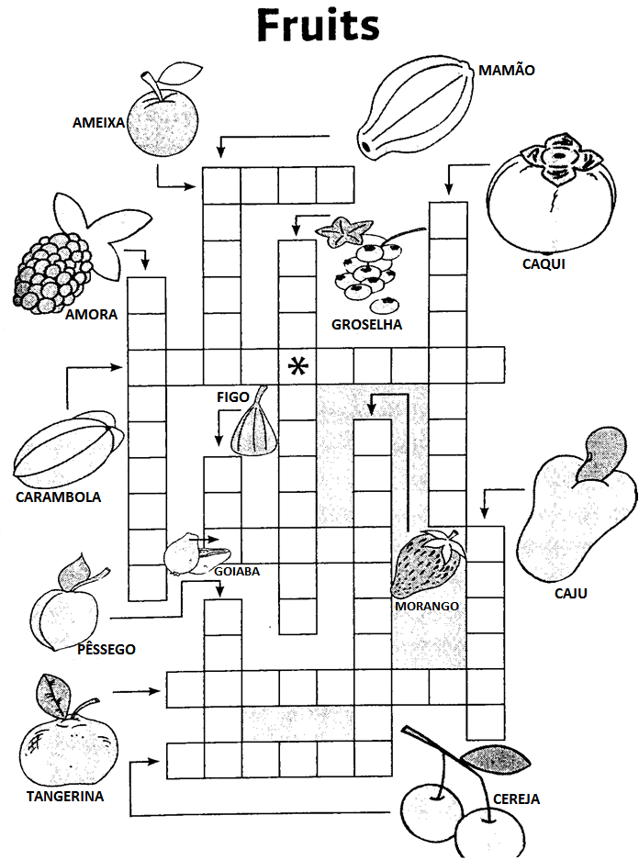
NAME:____________________________DATE:__________.

NAME:_________________________DATE:_________.

