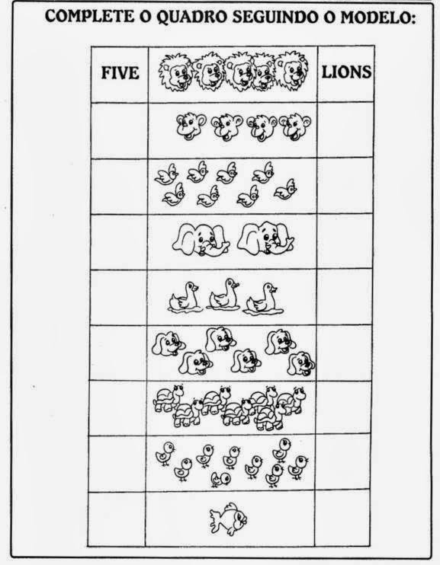
STUDENT:______________________________DATE:__________ STUDENT: ___________________________DATE:___________

